Professor
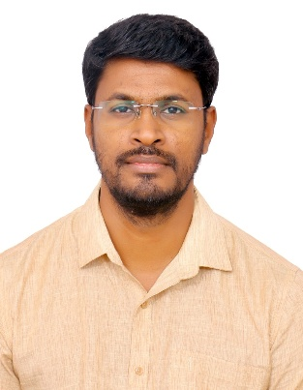

Dr. Gnanaprakash Kanagaraj

PhD Scholars

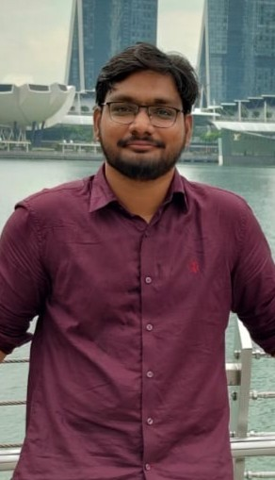 |  | 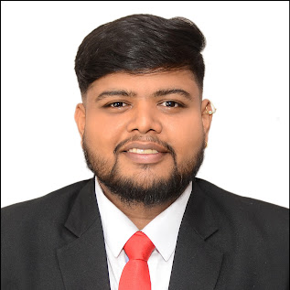
YSA Venkataram | Deepachanthiran RK | Rishabh Dhadiwal

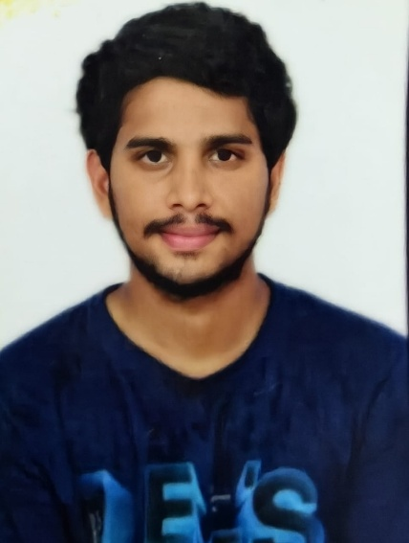 | 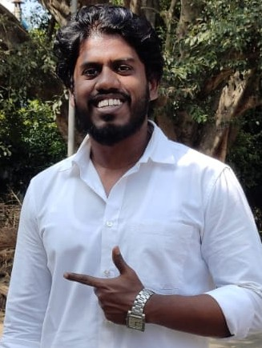
Mallidi Jaswanth Reddy | Senthil Kumar R

M. Tech Scholars
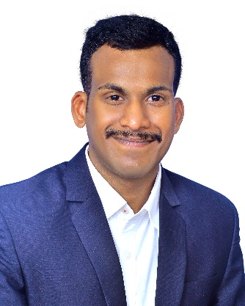 | 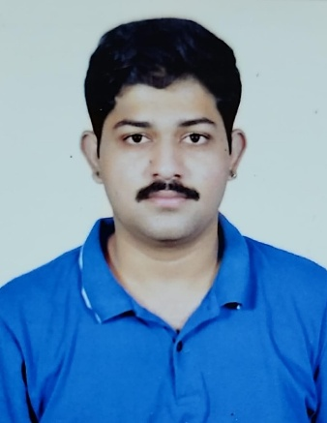 | 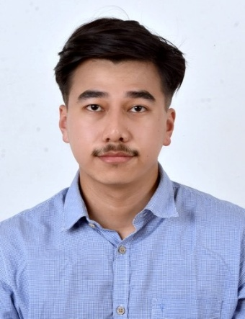
Harshavardhan Madishetti | Shanmukha Adithya Anupindi | Pangambam Lenin Singh



Arohi Mathur

Project Staffs
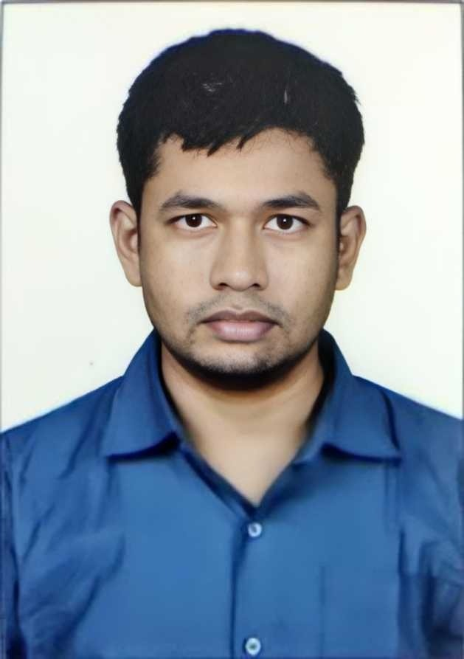 |  | 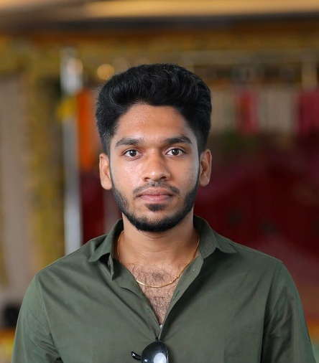
Dr. Rajneesh Kumar Yadav | Naresh Kumar | Vishnu Vikrama Simman R

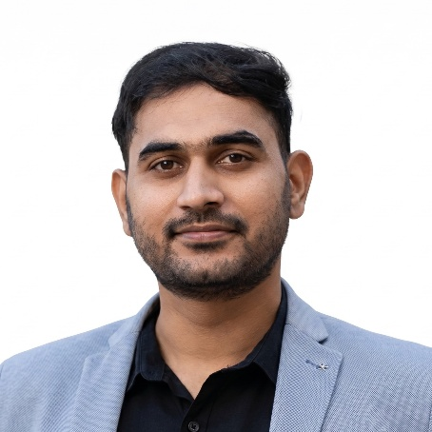 | 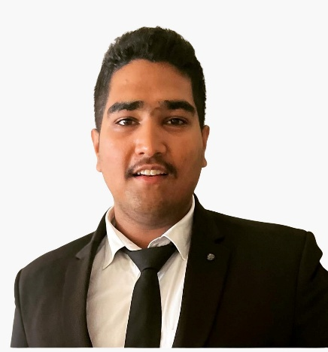
Arpit Dubey | MNS Harsha Vardhan

Alumni
 | 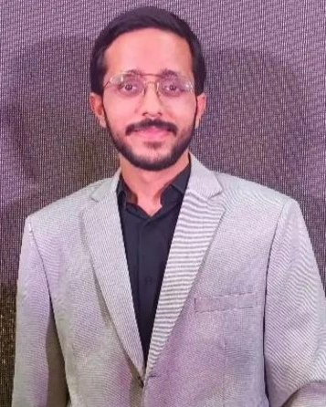 | 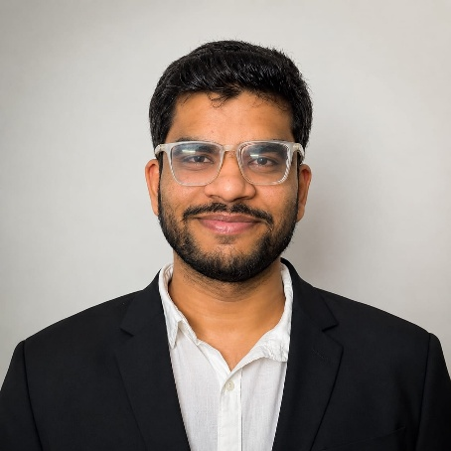
Prateek Jain | Abhik Mukhopadhyay | Shreyas Sahu

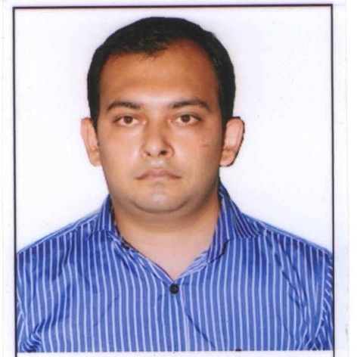

Amit Kumar Mishra | Sairaj Gaunekar

